ACCEPTANCE TEST PROCEDURE
FOR
RKVM

P.O. No. | BEPO/HD4/4000057921 | DATE: | 05/04/2016
PREPARED BY. | Mr. Purushotham Reddy | APPROVED BY. | Mr.Rajmohan
SIGNATURE. |  | SIGNATURE.
BEL (Rep) NAME | Mr. | APPROVED BY. | Mr.
SIGNATURE. |  | SIGNATURE.

Supplied To:
M/S. BHARAT ELECTRONIC
HYDERABAD

Manufactured By:
M/S. DATASOL (B) PVT.LTD.
# 793, 1st & Stilt Floor, Vyalikaval HBCS,
Behind BEL Corporate Office,
VeerannaPalya, Nagawara,
Bangalore - 560 045.


- SCOPE

This document defines the procedure that is to be followed during the process of Acceptance of the RUGGED KVM DSL-RKVM19-8838TB for fulfilling the needs of BEL Hyderabad, as per the Purchase Order which includes visual inspection, power ON functional tests and environmental tests as described.

IDENTIFICATION

The RUGGED KVM DSL- RKVM19-8838TB supplied by Datasol to BEL, Hyderabad, will be here after identified as given below.
Name | RUGGED KVM
Identification | RKVM19-8838TB

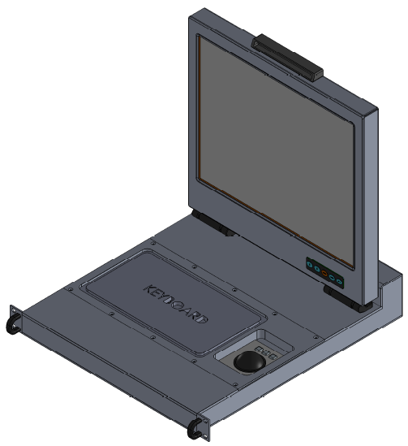

FIGURE 1: VIEW OF DSL-RKVM19-8838TB

1.2 KVM OVERVIEW
The KVM DSL-RKVM19-8838TBis providing the Human Machine Interface to the Missile Systems. It is rugged, 19” Rack mount, 2U, fitted with 88-key keyboard, track ball and TFT LCD module using amorphous silicon TFT’s as an active switching devices built for space-limited environments with high graphics demand. The built-in 19.0 inch TFT Display diagonally measured active area with UXGA resolutions.

1.3 DOCUMENT OVERVIEW
This document gives the detailed explanation of the procedures that is followed for testing RUGGED KVM DSL-RKVM19-8838TB.
Section 1 gives the brief description of the RUGGED KVM DSL-RKVM19-8838TB.
Section 2gives the detailed specification of the particulars that are installed in the RUGGED KVM DSL-RKVM19-8838TB.
Section 3 gives the detailed explanation of the Test processes / procedures along with test reports that are followed during the testing of the RUGGED KVM DSL-RKVM19-8838TB.
Section 4 Appendices
Appendix A: Assembly Drawings
Appendix B: Connector & Signal Details
1.4 REFERENCE DOCUMENTS
Specifications : Technical specification as given in PURCHASE ORDER.
Standards :
Other Publications : User Manual of KVM.

NAME PLATE DETAILS

NAME | RUGGED KVM
PART NO | DSL-RKVM19-8838TB
BEL PART NO | 446172260134
SERIAL NO* | XXXXYYZZZ
MANUFACTURER | DATASOL (B) PVT. LTD.
- Note

The Serial number is derived as mentioned below

XXXX constitutes the Year of Manufacturing

YY constitutes the Month

ZZZ constitutes for the serial number of the unit.

FIGURE 2: FRONT VIEW OF DSL-RKVM19-8838TB
FIGURE 3: REAR VIEW OF DSL-RKVM19-8838TB
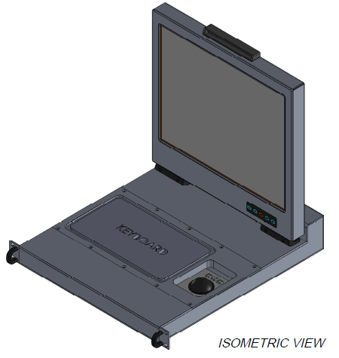
FIGURE 4: ISOMETRIC VIEW OF DSL-RKVM19-8838TB

FIGURE 5: TOP VIEW OF DSL-RKVM19-8838TB
- SPECIFICATIONS

Model : | DSL-RKVM19-8838TB
Size: | 2U 19” Rack mount type
Construction: | Aluminium Alloy
Keyboard: | Panel Mount, 88 Keys Keyboard with Integrated Backlight  Completely sealed NEMA 4X Casing
Tracker Ball: | Panel Mount, 38mm Phenolic Resin Black fully sealed
Dimension: | 482.6 * 88.0 * 500 mm
Weight: | 20 kg
Power Supply: | Industrial Level AC 100 / 240 V Auto Switching
Operating Temperature: | -10°C to 55°C
Drawer Design: | Single rails for entire KVM unit
KVM Interface: | Standard DVI Connector  Power through Circular Connector  Separate USB Circular connectors for Keyboard and Track Ball Interface  One USB Circular Connector Port for connecting External Mouse
  - RUGGED KVM ACCESSORIES

SL No | Instrument Title and Model Number | Qty
1 | KVM DSL-RKVM19-8838TB | 1
2 | Power cable with circular connectors 3106R-10SL-3S | 1

2.2 Functional Block Diagram of RUGGED KVM.
This display and driving circuit boards assembly inside of KVM Layout.
KVM REAL VIEW
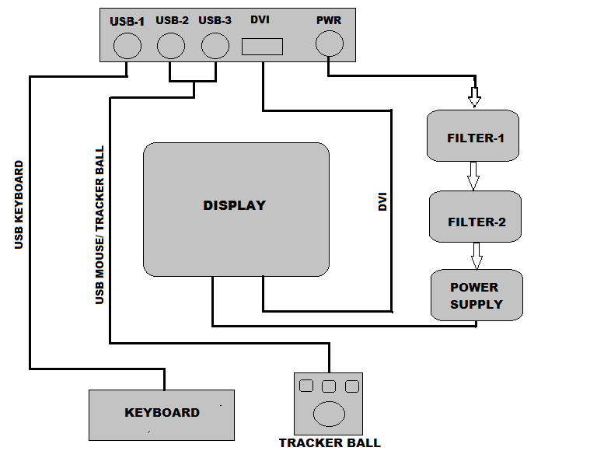

FIGURE 6: BLOCK DIAGRAM OFDSL-RKVM19-8838TB
  - Detailed Specifications of KVM Sub modules is as follows:

- MONITOR: 19" SXGA Industrial Open Frame Monitor
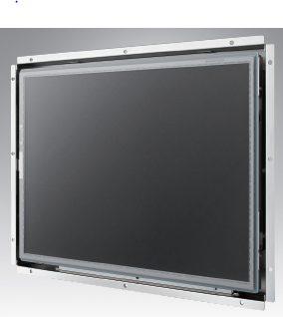

- 19" SXGA LCD panel with LED backlight for 20% power saving and environmental protection
- -20° C ~ +60° C operating temperature
- Dual signal interface with VGA & DVI
- Integrated bracket for easy installation
- Versatile mounting methods for rear mounting and VESA mounting
- Anti-Reflective treatment (optional)

- USB KEYBOARD:
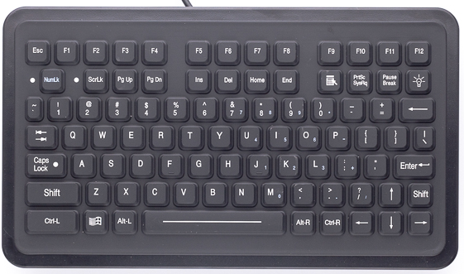

- MATERIAL: Industrial Silicone Rubber
- LIFE: Greater Than 10 Million Cycles TRAVEL: 0.055 in.
- ACTUATION FORCE: 7.05 oz. +/- 1.06oz (200g +/- 30g)
- FEEDBACK: Tactile with Mechanical Snap
- CABLE LENGTH: 4 feet (1.2 meters) DESIGN: Single-Cable USB Key Switch
- FLAMMABILITY PRINTED CIRCUIT BOARD : 94 VO SILICONE
- OVERLAY: 94 HB INTERFACE CABLE: 94 VO.
- Compatibility PS/2 KEYBOARD: All Windows Operating Systems USB KEYBOARD: All Windows and Macintosh OS
- Dimensions 11.80" x 6.79" x 1.35" (w-h-d) 299.7mm x 172.5mm x 34.3mm CUTOUT: 10.40" x 5.40" (w-h) 264.2mm x 137.2mm
- USB: 200mA@5V (from CPU port)

- USB TRACKBALL:

- POWER SUPPLY:

Max output wattage 75.6 & DC output 12V 6.3A.

2.4 TEST SETUP

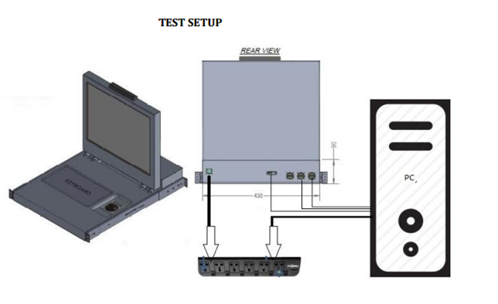

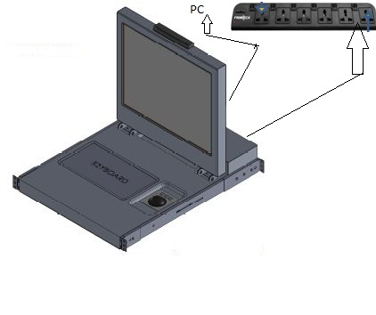
FIGURE 7: TEST SETUP OF DSL-RKVM19-8838TB

For testing KVM display Connect the USB Key board, USB Mouse / Traker Ball and the DVI cable to any Test system and switch on the KVM &PC, the system boots showing the display on the KVM screen. Check the resolution, it should be up to 1280 X 1024 . Also open any application & type to check the functionality of Keyboard & Trackball.

2.5 VISUAL INSPECTION
- The Color of the KVM should be Windows Grey RAL 7040.
- The Rugged KVM (DSL-RKVM19-8838TB) shall be free from any visible workmanship defects.
- All the fasteners shall be properly screwed, particularly check for the followings:
  - Both Handles are fitted firmly.
  - Check at the Rear Panel all MIL Circular connectors are as per the Rugged KVM configuration diagram, and are mounted firmly.
- Check for the Track ball moving properly without getting struck.
- After checking the KVM system as mentioned above and if it is Trouble free, then switch ON the KVM.

2.6Performance Check:

TABLE 1: PERFORMANCE CHECK
STEP | TEST | REQUIREMENT | RESULT
I | PHYSICAL INSPECTION
1 | Check the KVM for any damages | No damages | OK / NOT OK
2 | Check the power circular connector properly matted at the KVM end and also clearly inserted at the power socket. | Proper fitment | OK / NOT OK
3 | Check all the connectors power & signal | No loose pins / wires | OK / NOT OK
4 | Check all the fastners and screws are properly fixed and are in place | Proper fitment | OK / NOT OK
II. FUNCTIONAL TEST
1 | Power On Self Test:
Sl.No | FUNCTIONAL TEST | OBSERVE | REMARKS
1 | Fuctionality of KVM:  After switching ON the power to KVM & PC check the system got booted and display seen on the screen of KVM. Set the required Resolution and check if the set resolution is supported and displayed on the screen | Observe:  Resolution up to 1280 X 1024 | OK / NOT OK
2 | Functionality of Keyboard / Trackball:  After switching ON the power to KVM & PC check the system gets booted and display seen on the screen of KVM. Check the functionality of the keyboard by typing & Mouse by Tracking or changing the position. | Test by pressing the keys at keyboad & check the same is displayed on the screen at KVM display.  Move the traker Ball mouse &check if the moving is cursor is moving in line to the direction moved to check the mouse / Traker ball is working fine. | OK / NOT OK
Note : After checking the entire functions as shown above, shutdown the system.
2.7 ENVIRONMENT SPECS FOR QT: AS PER JSS 55555 STANDARDS
TABLE 2: ENVIRONMENT SPECS FOR QT: (RUGGED KVM)
(Equipment under ON Condition during the operational test
SL.No | Type Of Test | Reference |  | Specifications | Remarks
1 | Vibration  (Endurance) | Ref | JSS-55555:2000 | Sinusoidal sweep vibration:  5 to 8 Hz : ±6 mm constant displacement  8 to 500 Hz : ±1.5g constant acceleration  Swap rate:1 Oct/min  Equipment will be in OFF condition.  Test duration: 1 hour in each X,Y&Z axis. | Switch ON the UUT and carry PC at the end of testing on each axis
1 | Vibration  (Endurance) | Test No | 28
1 | Vibration  (Endurance) | Table No | 4.28.2
1 | Vibration  (Endurance) | SL.No | 1b
2 | High Temperature  (Operational) | Ref | JSS-55555:2000 | Test condition K,  Temp +55° C ±3 C  Test duration : 16 hours | PC duration last 30 Minutes
2 | High Temperature  (Operational) | Test No | 17 |  | PC duration last 30 Minutes
2 | High Temperature  (Operational) | Procedure | 6 |  | PC duration last 30 Minutes
3 | High Temperature  (Storage) | Ref | JSS-55555:2000 | Test condition K,  Temp +70° C ±3° C  Test duration : 16 hours | PC after 2-4 hours recovery at the room temperature
3 | High Temperature  (Storage) | Test No | 17 |  | PC after 2-4 hours recovery at the room temperature
3 | High Temperature  (Storage) | Procedure | 6 |  | PC after 2-4 hours recovery at the room temperature
4 | Damp Heat | Ref | JSS-55555:2000 | +40° C ±2° C ,95 ±5 % RH  Test duration : 16 hours | PC duration last 30 Minutes
4 | Damp Heat | Test No | 10 | +40° C ±2° C ,95 ±5 % RH  Test duration : 16 hours | PC duration last 30 Minutes
5 | Low Temperature  (Operational) | Ref | JSS-55555:2000 | Test condition H,  Temp -10° C ±3° C  Test duration : 16 hours | PC duration last 30 Minutes
5 | Low Temperature  (Operational) | Test No | 20 |  | PC duration last 30 Minutes
5 | Low Temperature  (Operational) | Procedure | 4 |  | PC duration last 30 Minutes
6 | Low Temperature  (Storage) | Ref | JSS-55555:2000 | Test condition J,  Temp : -20° C ±3° C  Test duration : 16 hours | PC after 2-4 hours recovery at the room temperature
6 | Low Temperature  (Storage) | Test No | 20 |  | PC after 2-4 hours recovery at the room temperature
6 | Low Temperature  (Storage) | Procedure | 4 |  | PC after 2-4 hours recovery at the room temperature
7 | Altitude | Ref | JSS-55555:2000 | Test condition L2A2,  Temp : -10° C ±3° C Altitude :4160 meters for 16 hours | PC duration last 30 Minutes
7 | Altitude | Test No | 3 |  | PC duration last 30 Minutes
7 | Altitude | Table No | 4.3.2 |  | PC duration last 30 Minutes
7 | Altitude | Procedure | 5 |  | PC duration last 30 Minutes
NOTE: One unit of the entire lot will undergo the mentioned Qualification Tests

TABLE 3: ESS TEST SPECIFICATIONS
2.8DETAILED ESS TEST SPECIFICATION AS PER MIL STD- 810E
Sl No | PARAMETER | TEST DESCRIPTION |  | Remarks
1 | Random vibration-pre Thermal cycling | 20Hz-80Hz , sloping at +3dB/octave:  80Hz to 350Hz, 0.02 g2/Hz PSD, 350-2000Hz,sloping at -3dB/octave.  5min. per axis on all three axes.
2 | Thermal cycling | -10° C to +55° C  Dwell AT -10° C and +55° C for 1 hour.  No.of cycles:10  Rate of cooling/heating: 5° C /minute
3 | Random vibration-post Thermal cycling | 20Hz-80Hz , sloping at +3dB/octave:  80Hz to 350Hz, 0.02 g2/Hz PSD, 350-2000Hz,sloping at -3dB/octave.  5Min.per axis on all three axes.
NOTE: Except the QT Unit all other units of the entire lot has to under go ESS

TABLE 4: EMI / EMC TEST SPECIFICATIONS
EMI/EMC Specifications : As per MIL STD-461E/F
Sl.No | PARAMETER | Test | TEST DESCRIPTION | Remarks
1. | MIL STD-461E/F | CE102, | Conducted Emissions, Power Leads. 10 KHZ to 10 MHZ
2. | MIL STD-461E/F | RE102, | Radiated Emission, Electric field. 2 MHZ to 18 GHZ
3. | MIL STD-461E/F | CS101,
4. | MIL STD-461E/F | CS114, | Conducted susceptibility, bulk cable injection. 10 KHZ to 200 MHZ
5. | MIL STD-461E/F | CS115, | Conducted susceptibility, bulk cable injection. Impulse Excitation
6. | MIL STD-461E/F | CS116, | Conducted susceptibility, damped sinusoidal transients.Cables and power leads.10 KHZ to 100 MHZ
7. | MIL STD-461E/F | RS103 | Radiated susceptibility, Electric Field. 2 MHZ to 18 GHZ

2.9 EMI / EMC and Envornmental Test Results
Measurement reports for all EMI / EMC tests and Envornmental tests can be taken from lab for reference and only pass or fail needs to be filled in test data sheet below.

Indicate Pass / Fail or NA (Not Applicable) for each column.

TABLE 5: EMI/EMC AND ENVORMENTAL RESULTS

RUGGED KVM FUNCTIONAL TEST REPORT

DATE ://

PROJECT. |  | CLASS OF TEST.
UNIT. | RUGGED KVM | CLASS OF TEST.
UNIT NO. |  |  | PREET INSET POET

S.NO. | TEST | EXPECTED | OBSERVED | REMARKS
1. | Rugged KVM :  After switching ON the power to KVM & PC,check the system got booted and display seen on the screen of KVM. Set the required Resolution and see if the same is set on the KVM Display | Resolution up to  1280 X 1024
2. | Functionality of Keyboard / Trackball:  After switching ON the power to KVM & PC, check the system gets booted and display seen on the screen of KVM. Check the functionality of the keyboard by typing & Mouse / Tracker Ball by changing the position or moving the mouse. | Test by pressing the keys at keyboad & check the same is displayed on the screen at KVM.  Move the mouse / Move the ball of the Traker ball mouse and check if the cursor of the mouse is moving in line you’re your movement and is working fine.

TEST PASSED FAILED

OBSERVATIONS:

PROJ QC FIRM REP PROJ MANAGER
3.0 APPENDICES

3.1 APPENDIX A: Mechanical Drawing

2D Closed Condition

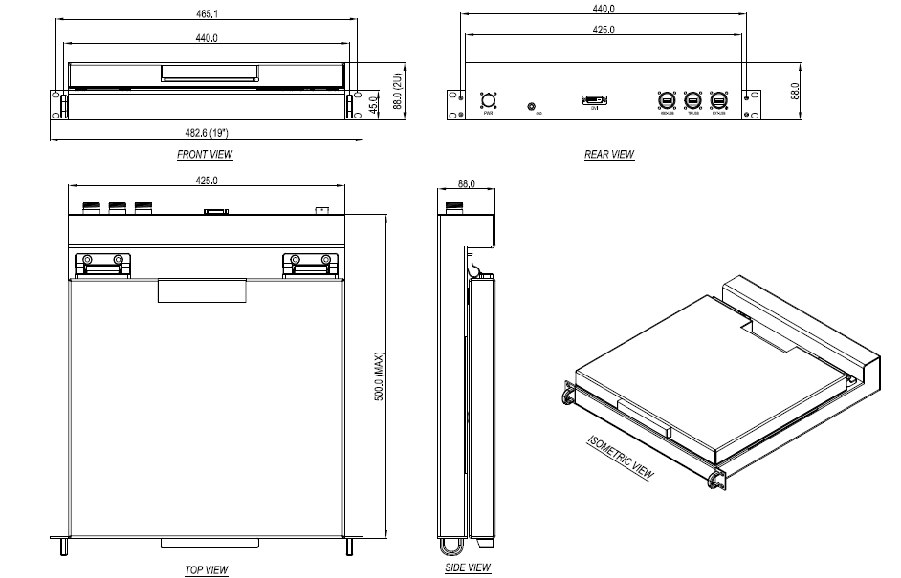

3D Closed Condition

3D OPEN CONDITION

2D DRAWING OPEN CONDITION

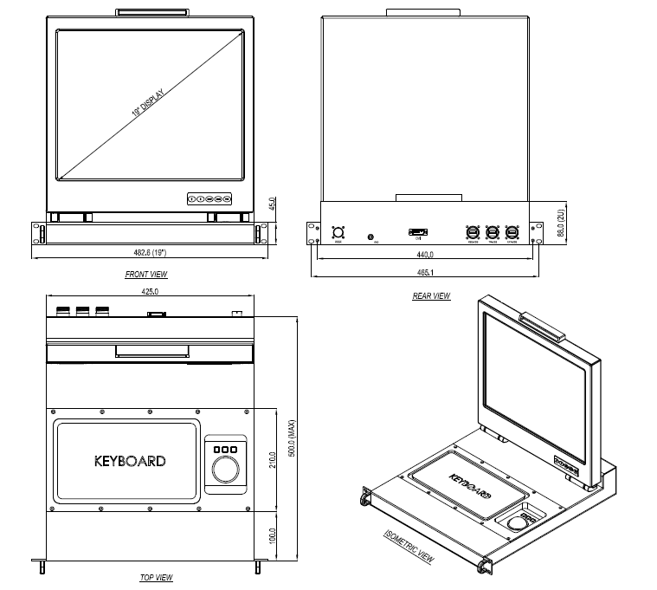

DIMENSIONS OF INDIVIDUAL COMPONENTS:
- Monitor : 396.0 (W) X 324.0 (D) X 18.0 (H)
- Functional Keyboard : 299.7 (W) X 172.5 (D) X 34.3 (H)
- Power Supply : 150.0 (W) X 50.0 (D) X 34.0 (H)
- Tracker Ball : 78.0 (W) X 58.0 (D) X 36.17 (H)
- KVM :15Kgs (approx.) (Dimensions as mentioned in Mechanical drawing)

3.2 Rear Panel Connectors
SL No | Instrument Title | Model Number | Qty
1 | Power cable with circular connector | MS 3106R-10SL-3S | 1
2 | DVI-I Standard connector | Standard DVI port | 1
3 | USB connector | USB FTV 21G | 3

4.0 APPENDIX B: CIRCULAR CONNECTOR & SIGNAL DETAILS

USB CONNECTOR

connector | Pin No | Signal Description
USB FTV 21G (3Nos) | 1 | USB POWER Vcc
USB FTV 21G (3Nos) | 2 | DATA -
USB FTV 21G (3Nos) | 3 | DATA +
USB FTV 21G (3Nos) | 4 | GROUND

DVI CONNECTOR
DVI -Ports | Pin No. | Signal
DVI | 1 | DVI-TMDS-C-DATA2
 | 2 | DVI-TMDS-C-DATA2
 | 3 | GND
 | 4 | NC
 | 5 | NC
 | 6 | DVI-DDC-SCLK
 | 7 | DVI-DDC-SATA
 | 8 | NC
 | 9 | DVI-DDC-SDATA1
 | 10 | DVI-TMDS-C-SDATA1
 | 11 | GND
 | 12 | NC
 | 13 | NV
 | 14 | .+5V-DVI
 | 15 | GND
 | 16 | DVI-HPD
 | 17 | DVI+TMDS-C-DATA0#
 | 18 | DVI+TMDS-C-DATA0
 | 19 | GND
 | 20 | NC
 | 21 | NC
 | 22 | GND
 | 23 | DVI_TMDS_C_CLK
 | 24 | DVI_TMDS_C_CLK#
POWER CONNECTOR

connector | Pin No | Signal Description
MS3102R10SL-3P | A | LINE
MS3102R10SL-3P | B | NEUTRAL
MS3102R10SL-3P | C | EARTH

5.0 LIST OF DELIVARABLES
 | DESCRIPTIONS | PRODUCTS | Qty
1 | RUGGED KVM | DSL-RKVM19-8838TB | 1 No
2 | POWER CABLE | CIRCULAR POWER CABLE | 1 No
3 | RUGGED KVM | USER MANUAL | 1 No

